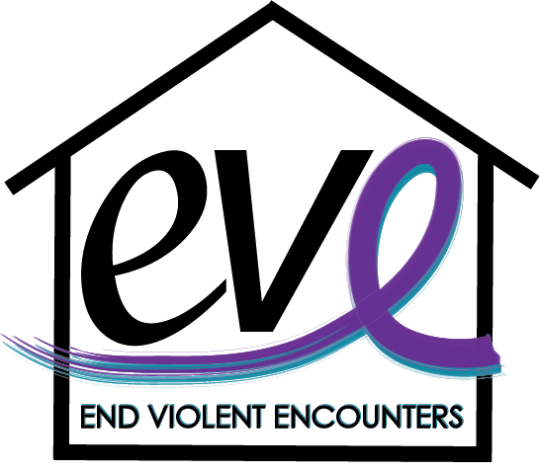
Sexual Assault Awareness Program

Did you know? Every 73 seconds, an American is sexually assaulted.
And every 9 minutes, that victim is a child. Meanwhile, only 5 out of every 1,000 perpetrators will end up in prison.

What is Sexual Violence?
Sexual violence means that someone forces or manipulates someone else into unwanted sexual activity without their consent. Reasons someone might not consent include fear, age, illness, disability, and/or influence of alcohol or other drugs.

Target Audience: Any

Program Description
This training program is geared toward raising awareness around the topic of sexual assault, the services EVE offers to survivors, how to connect someone to those services and other ways you can assist them on their journey of healing. Through this program, you will develop competencies in common myths associated with sexual violence, information on drug facilitated sexual assault, what consent is and specific examples of what consent sounds like. This program will also help expand your knowledge of local services and resources to help empower survivors.

Program Objectives
- Define what sexual violence is and who it affects.
- Recognize and understand the dynamics of drug facilitated assaults.
- Learn how technology is contributing to sexual violence with topics on sexting and revenge porn and how it can be navigated with teens and adults.
- Learn to debunk the myths of sexual violence and tackle one of the most commonly asked questions. “Why didn’t they fight back?”
- Become aware of local resources available to assist survivors who are experiencing domestic violence and how you can help them if you suspect they are in an unhealthy relationship.

*Additional learning objectives can be added to tailor this training

Contact Information
EVE (End Violent Encounters), Inc.
Leah Dryer  Director of Community Outreach  ldryer@eveinc.org  (517) 372-5976 Ext. 111 | Sam Stiles  Community Outreach Coordinator  sstiles@eveinc.org

